**Ideation Phase**

**Define the Problem Statements**

|  |  |
| --- | --- |
| Date | 19 September 2022 |
| Team ID | PNT2022TMID34993 |
| Project Name | Project - Trip Based Modelling of Fuel Consumption in Modern Fleet Vehicles Using Machine Learning |
| Maximum Marks | 2 Marks |

**Example:**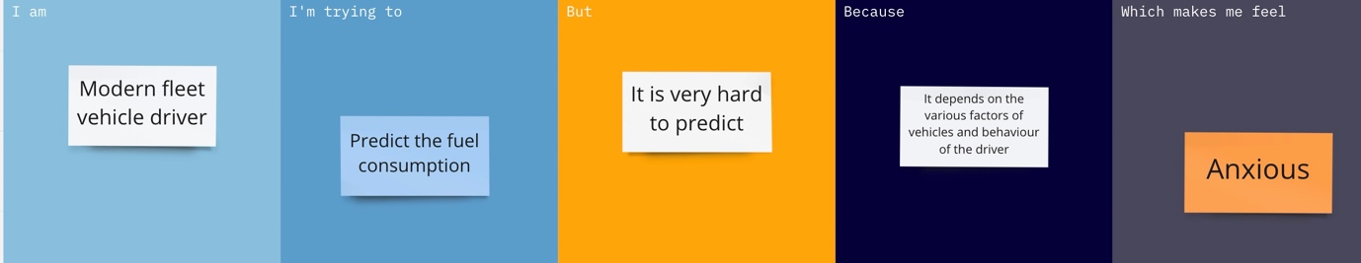

|  |  |  |  |  |  |
| --- | --- | --- | --- | --- | --- |
| **Problem Statement (PS)** | **I am (Customer)** | **I’m trying to** | **But** | **Because** | **Which makes me feel** |
| PS-1 | Driver | Predict the fuel consumption | It’s hard to predict | It depends on various factors and driver behaviour | Anxious |
| PS-2 | Driver | Monitor fuel level | It cannot forecast  properly | It’s depends on the level of load | Frustrated |